Analyst’ Notes:

* The results were rectified using the correct equation as stated in the inception report. Previous attempts were incorrect due to the misuse of the constants where it was intended for the Tagoloan project rather than of Cagayan’s constants for the rating curve.
* In this document is the sample of the rectified results with added features to the graph and excel sheet:
  + Dates on the Summative Excel sheet is now in Excel’s time format for replicability
  + Weekly and Daily plots are now added to the generation of the data
  + A moving average is used to see the general trend of the plot. (Smoothing)
  + For the weekly plot, a candle chart is generated to see both the median, average, and variations of the data in the given month.
  + The Daily plot is similar to the previous iteration of the plot but is aggregated on a per day basis
  + A 3-day window is used for all moving averages.
  + A new excel sheet is generated with the raw data that generates the graphs for the weekly and daily plots
  + For the raw graphs (Hourly data), peaks are added to showcase the events

Sample Discussion

Precipitation

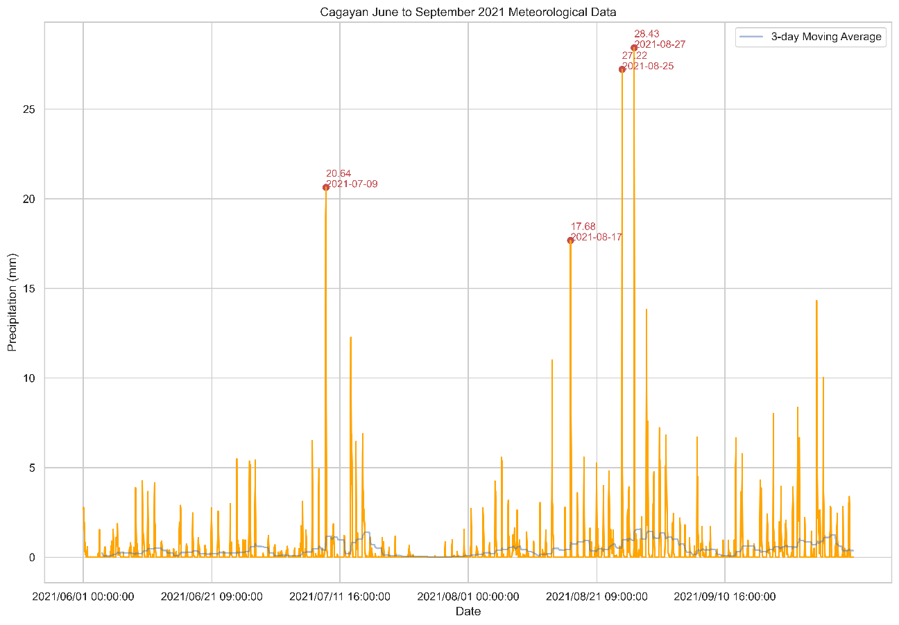

Figure 1 June to September 2021 Meteorological Data

1. The highest precipitation reading for Cagayan River was recorded at 28.43 mm which was preceded by the second highest reading of 27.22 just two days before.
2. As per the trendline, sustained rainfall was observed on early August 2021 which extends to the end of September, causing a period of continuous rainfall indicative to a recharge of the reservoir.
3. From mid-July to early August, there was a period of significantly less rainfall which may affect the head of the river section resulting to a lower power potential of the river for HPP usage.­

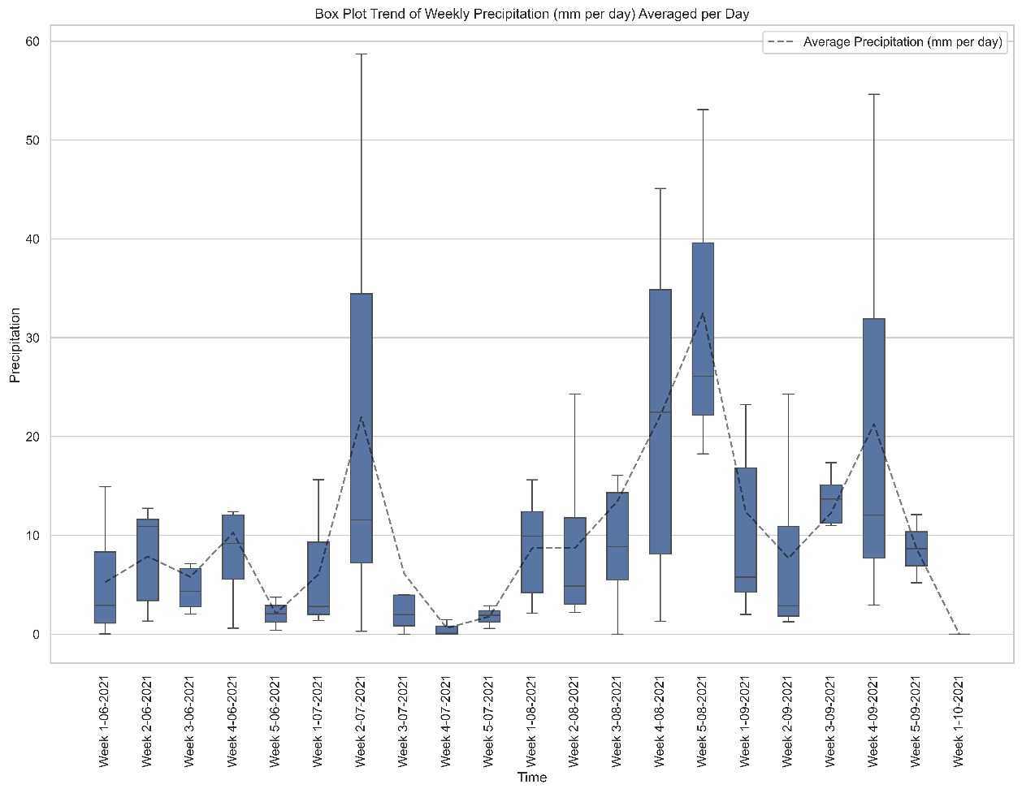

Figure 2 June to September 2021 Weekly Meteorological Data Box Plot

1. On the second week of July, there was a significant variance to the reading where the maximum, disregarding outliers, reached a peak of about 58mm per day.
2. However, despite the noted maximum, August 2021 and September 2021 were the most affected by precipitation indicative from the width of the trend in comparison the months of June and July.
3. The driest week occurred on the fourth week of July with an average and median approaching 0mm. (Refer to Figure 1 for the hourly meteorological readings)

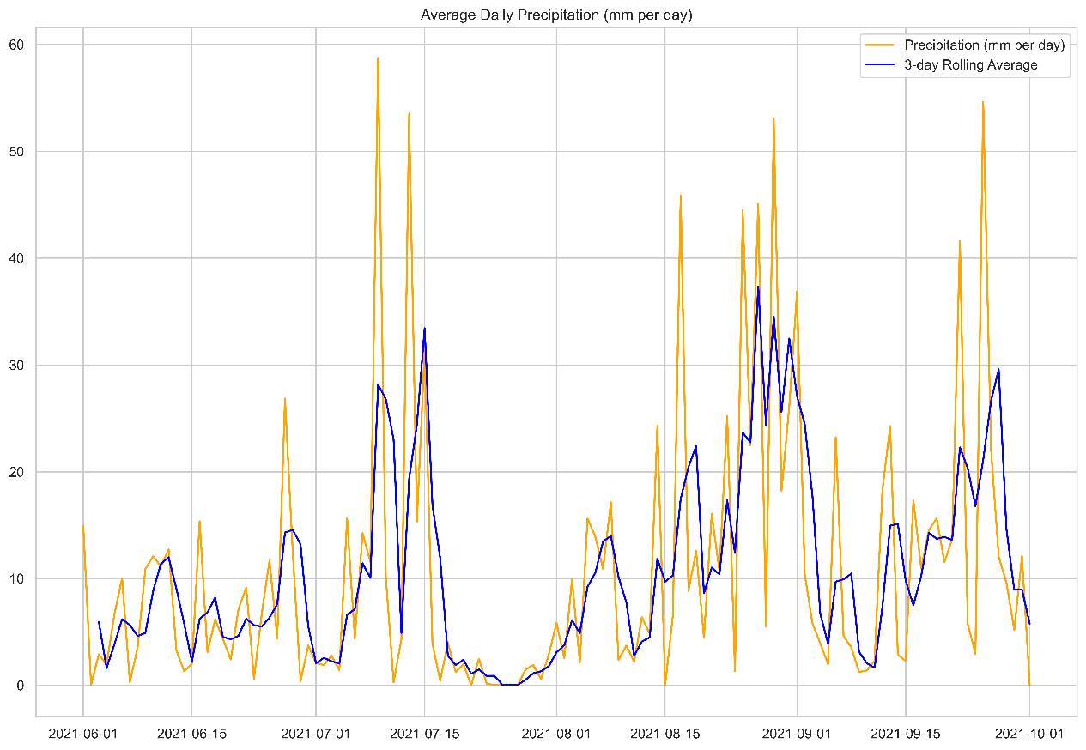

ANNEX: June to September 2021 Daily Precipitation

Water Level

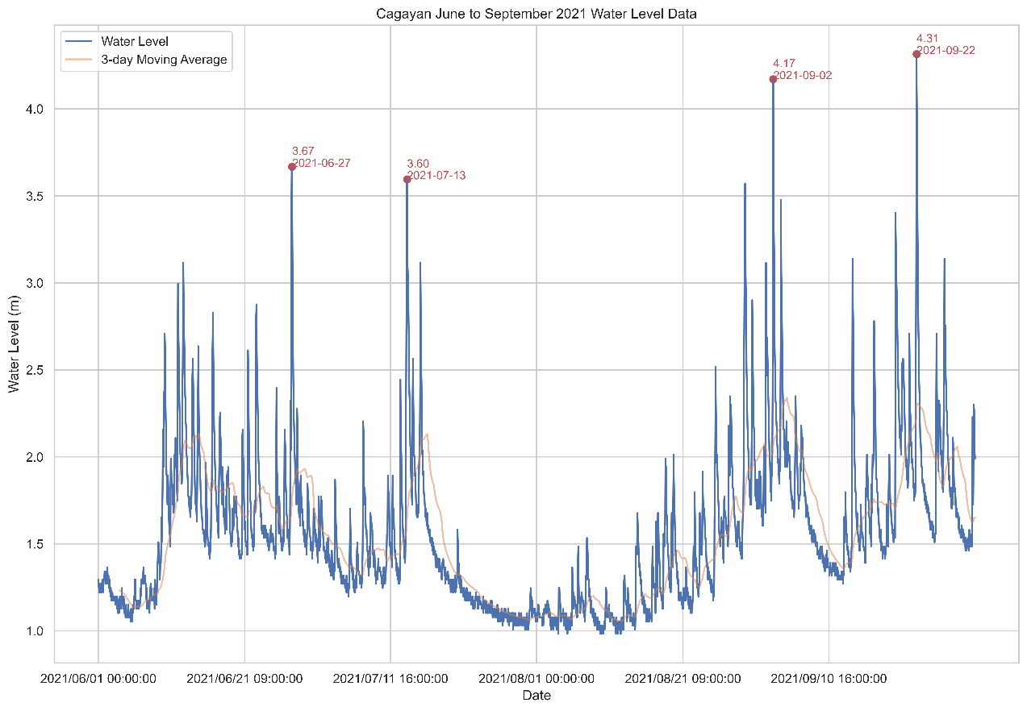

Figure 3 June to September 2021 Water Level Data

1. For the collected water level readings, the highest recorded datum was 4.31 m on September 22.
2. The plot follows a similar trend with precipitation albeit a lag time of 1 week until time of saturation before the runoff dictates the effective stage of the river. This is observed in comparison with the time of occurrence of the highest precipitation and the second highest water level reading.
3. Starting from late July up until early August, the stage was low. This can be attributed to the low rainfall received by the tributaries as shown on figures 1 and 2 from the precipitation of the area.

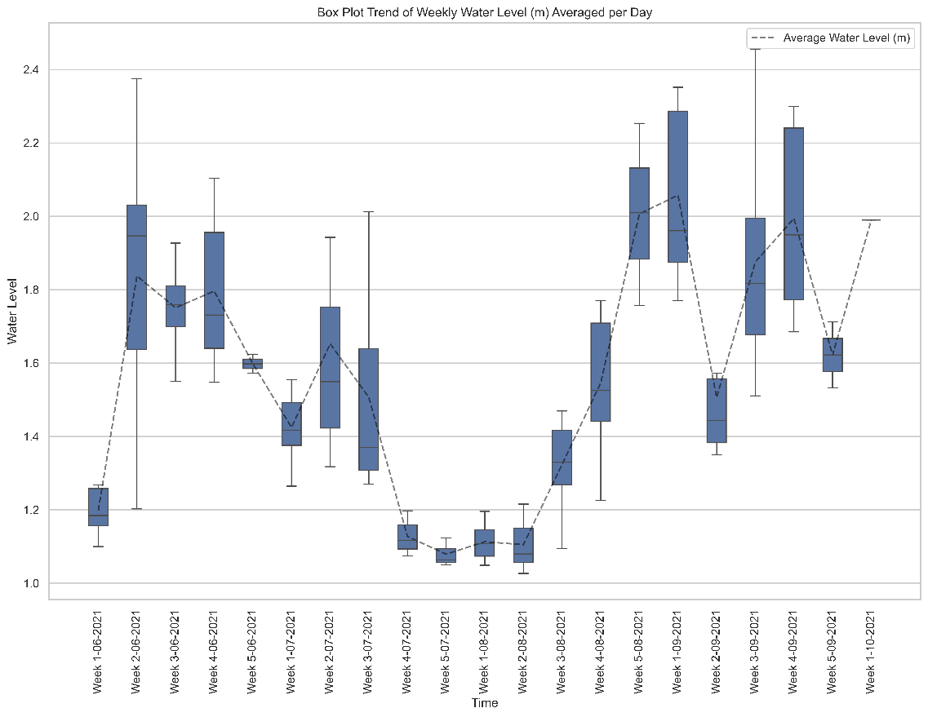

Figure 4 June to September 2021 Weekly Water Level Data Box Plot

1. When averaged by a weekly basis, the lowest stage height of the river is approximately 1.1m which occurs on the last week of July until the second week of August.
2. The graph also shows that the river’s cross section has reliably stayed above the minimum stage height on the months of August and September.

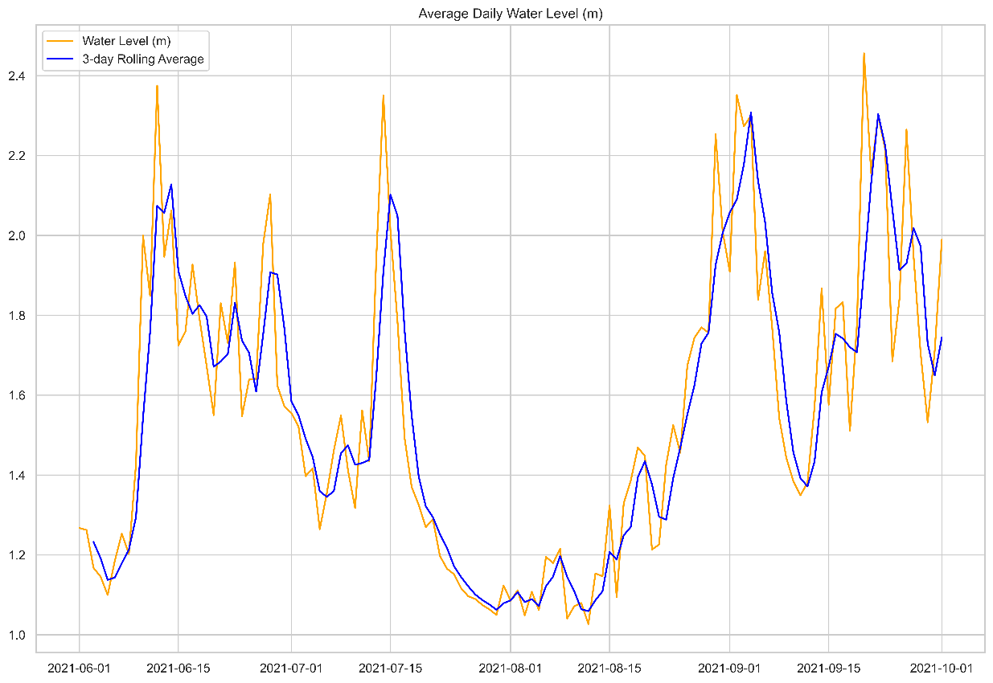

ANNEX: June to September 2021 Daily Water Level

Discharge 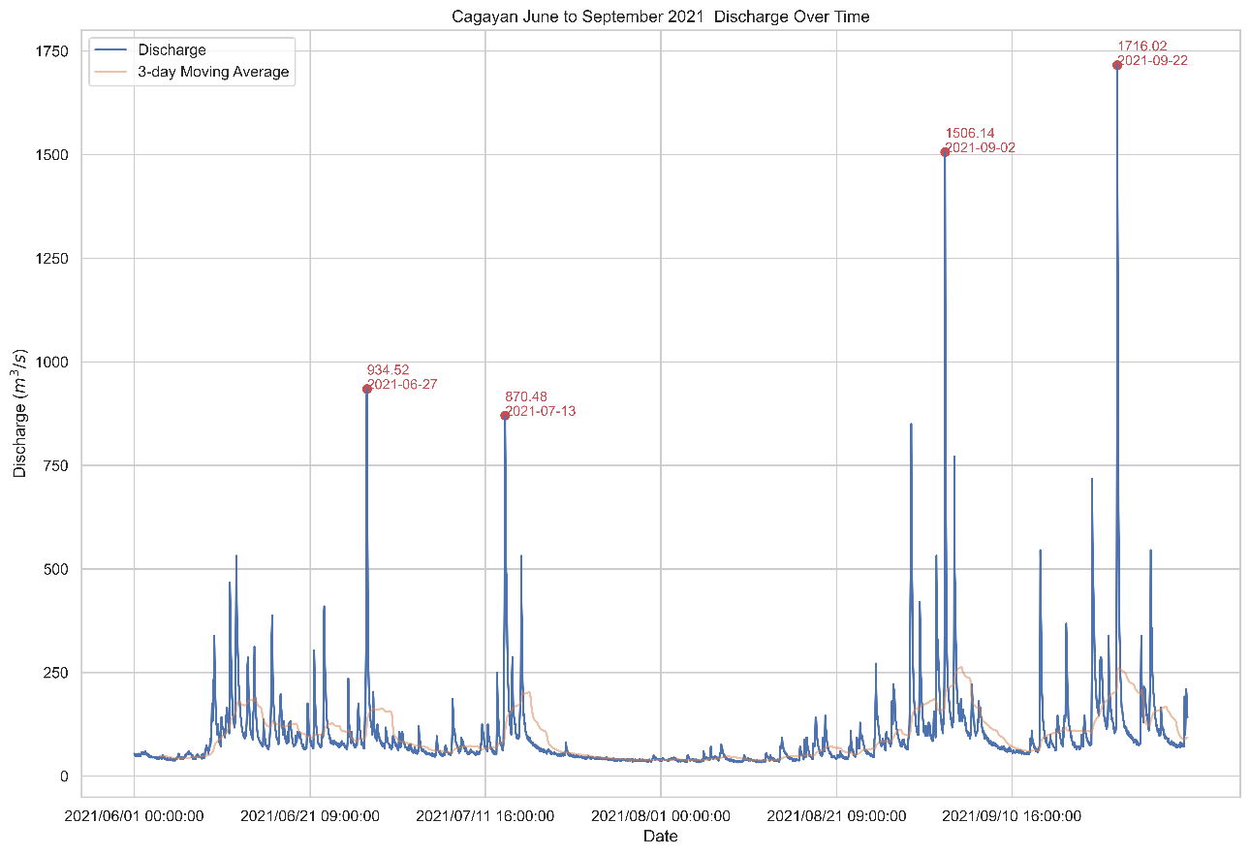

Figure 5 June to September 2021 Discharge Data

1. As shown in Figure 5, the highest discharge data was observed in September 22, 2021, similar that of the water level since the data was derived using the rating curve. However, the variation of the flow is apparent when looking at the peaks in comparison with the minimum flow rate.
2. In August and September, there are more flow events indicated by the sharp peaks in comparison to June and July. Late July and early August however shows that there is no significant uptake inflow which can be attributed to the low precipitation readings stated above.

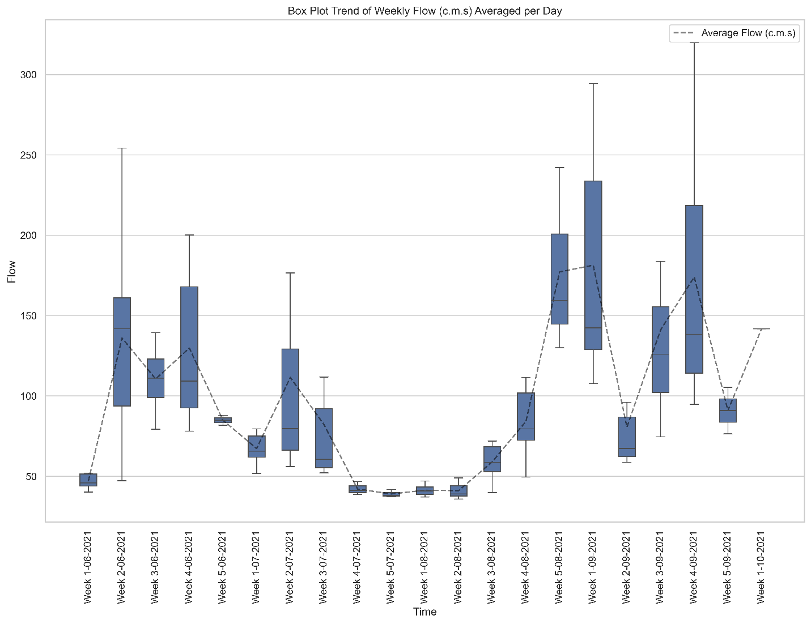

Figure 6 June to September 2021 Weekly Discharge Data Box Plot

1. Looking at Figure 6, it is apparent that late August and the whole month of September produces the most amount of flow, whereas June and July produce the least amount of volume with July being the least.
2. The trend follows an upward motion indicating that the flow is increasing for the said months. This defers with the climatological normals of the nearest weather station, Malaybalay, from DOST-PAGASA where July is part of the rainy season (global maxima on June and plateaus until October). This indicate there was a drought on this said month given the low precipitation and stage of the river.

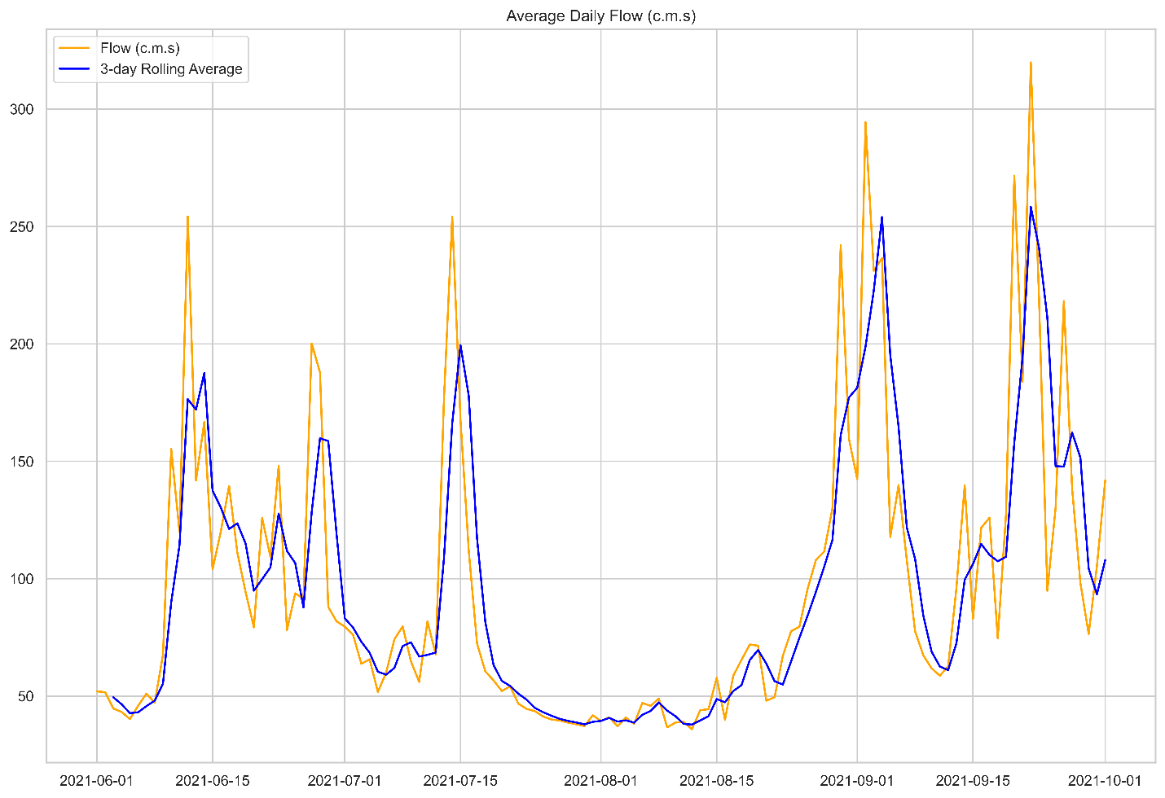

ANNEX: June to September 2021 Daily Discharge Level